

EVENTS

2014 – 2015

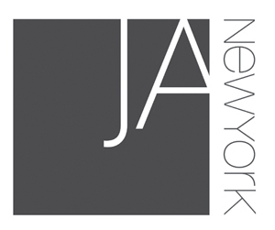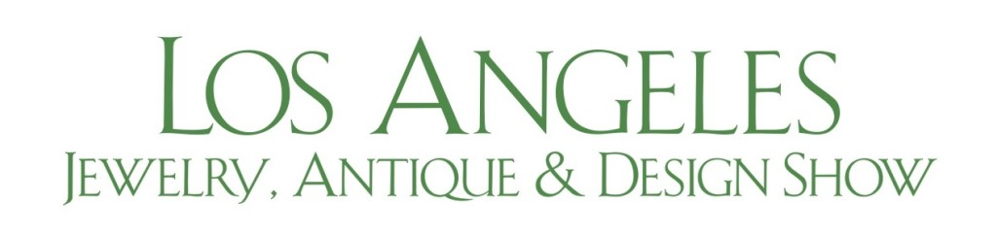

|  |  |  |
| --- | --- | --- |
| 2015 | 6- 8 September | International Jewellery London, London, UK |
| 2015 | May 29 – June 1 | JCK Las Vegas, Las Vegas, USA  Editors Choice Award- Voted Top 3 |
| 2015 | April | A’ Design Award winner |
| 2015 | 18 – 25 April | A' Design Winners' Exhibition at "MOOD"  Ex Chiesa di San Francesco, Como, Italy |
| 2015 | 14 – 18 January | Los Angeles Jewelry, Antiques, Design  Los Angeles, USA |
| 2014 | 27 – 29 July | JA NY summer show, New York, USA  Selected for “New Designer Gallery” |

EVENTS

2014 - 2015

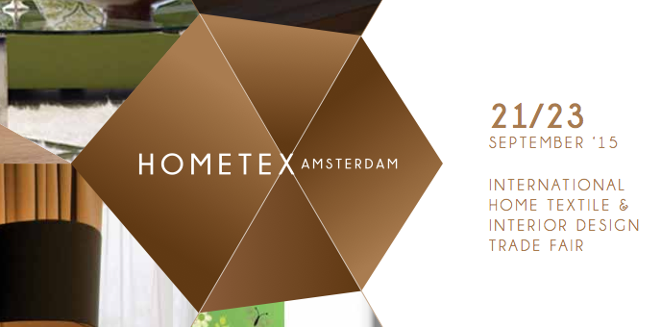

|  |  |  |
| --- | --- | --- |
| 2015 | 21 – 23 September | A' Design Winners' Exhibition at "Hometex", Amsterdam, Netherlands |
| 2015 | 1 – 30 October | A' Design Winners' Exhibition at "MOOD", Dublin Castle, Dublin, Ireland |

THEY ARE WEARING OUR JEWELLERY

**2015, February; Cheryl Boone Isaacs, Academy President**, during 87th Annual Academy Awards Nominee Luncheon

THEY ARE WRITING ABOUT US

2014 - 2015

|  |  |
| --- | --- |
|  |  |
|  |  |
|  |  |